**Information System Management Lab**

**BCOM 307**

**Assignment #4**

***Submitted by:***

**Name:** YASH JAIN

**Enrollment No:** 03914788818

**Semester:** 5th Sem

**Class:** B.Com(H)

**Section**: BCom 5A

**Date of Submission**: 10/09/2021

***Submitted to:***

**Praveen Kumar Singh**

**Assistant Professor, MAIMS**



**Department of Commerce**

**Maharaja Agrasen Institute of Management Studies**

**Affiliated to Guru Gobind Singh Indraprastha University, Delhi**

**Sector -22, Rohini, Delhi -110086, India; www.maims.ac.in**

Maharaja Agrasen Institute of Management Studies

Affiliated to GGS IP University; Recognized u/s 2(f) of UGC Recognized by Bar Council ofIndia; ISO 9001: 2015

Certified Institution Sector 22, Rohini, Delhi -110086, India; [www.maims.ac.in](http://www.maims.ac.in/)

Department of Commerce

Academic Year: 2020-21

Semester: Vth

# Assignment No.4

# Unit No: 1

**Course/Subject Code:** BCOM 307 **Subject Title: Information System Management Lab**

# Issue Date: Last Date of Submission:

**Instructions for Students:**

# All Questions are Compulsory.

1. The student should attach proper cover page for each assignment clearly mentioning the Assignment No.
2. Each assignment should be prepared by the student individually with proper explaination and screenshots.
3. A4 size ruled sheets should be used for the assignment.
4. Assignment pages should be serially numbered at the bottom of page.

***During online education mode, upload scanned copy of the complete assignment including cover page latest by due date.***

|  |  |  |
| --- | --- | --- |
| **Question No.** | **Question** | **CO No.** |
| 1 | Find out the names of all the clients. | **CO1** |
| 2 | Retrieve the entire contents of the client_master table. |
| 3 | Retrieve the list of names and city of all the clients. |
| 4 | Delete from client_master where the column state holds the value 'rajasthan' |
| 5 | Insert a row into the table client_master where client no is 107,name is Max, city is Mumbai, pincode is 400054, State is Maharashtra, balance due is 15500. |
| 6 | Delete all the records from client_master table with baldue<10,000. |

**ASSIGNMENT 4 - PRACTICE FOR BASIC TABLE COMMANDS**

**Task 1 : Find out the names of all the clients.**

The following task is completed using the **‘select’** command.

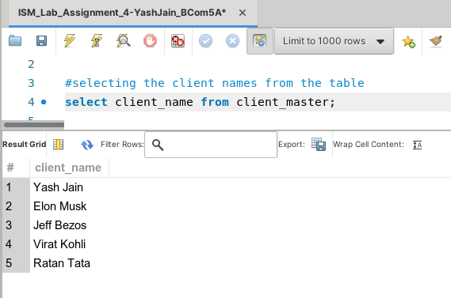

**Task 2: Retrieve the entire contents of the client_master table.**

The given task can be completed using the **‘select’** command.

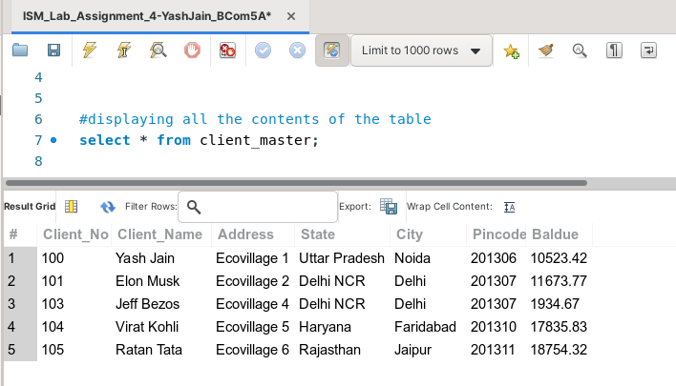

**Task 3: Retrieve the list of names and city of all the clients.**

This task can be completed by using the command **‘select’.**

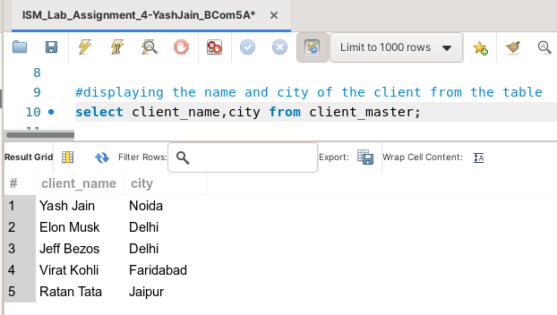

**Task 4: Delete from client_master where the column state holds the value 'rajasthan'.**



(before deletion)

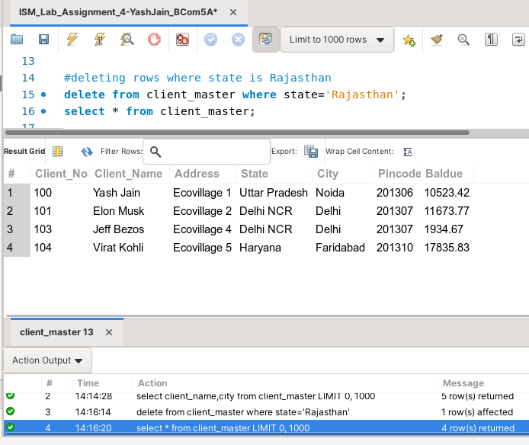

(after deletion)

**Task 5: Insert a row into the table client_master where client no is 107,name is Max, city is Mumbai, pincode is 400054, State is Maharashtra, balance due is 15500.**

To complete this task, we use the **‘insert into’** keyword, along with the **‘values’** clause.

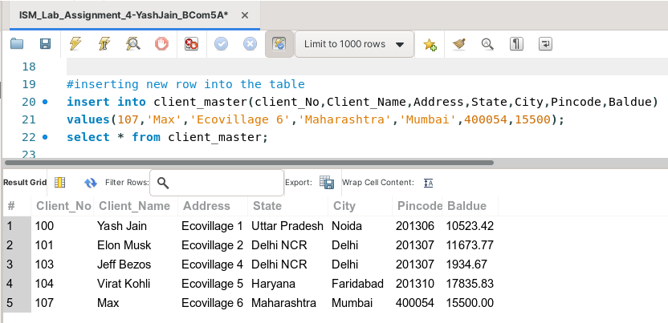

**Task 6: Delete all the records from client_master table with baldue <10,000.**

To complete this task, we use the **‘delete’** keyword, along with the **‘where’** clause.

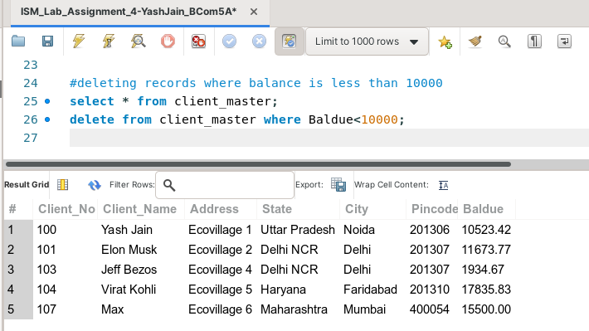

(before deletion)

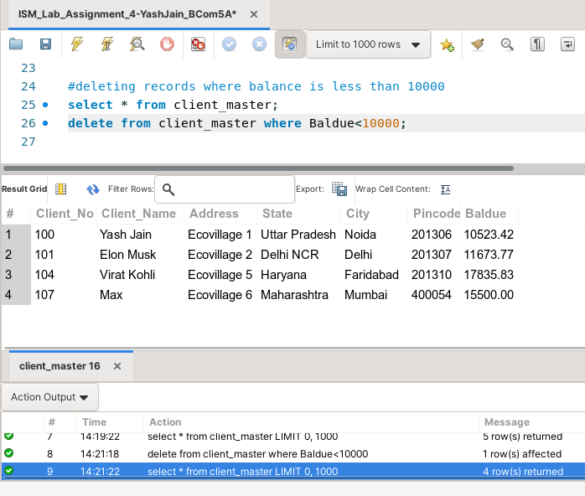

(after deletion)